**The Hostage**

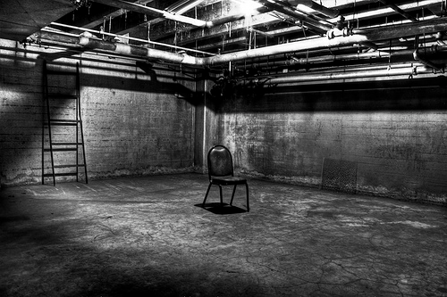

Douglas C.

Ryan H.

Anson C.

Talib R.

Gregg C.

**Table of Contents:**

Pg. 1 -- Title Page

Pg. 2 -- Table of Contents

Pg. 3-4 -- Team Description and Contributions

Pg. 4 -- Timeline

Pg. 5 -- Game Overview and Mechanics

Pg. 6 -- Story, Setting, and Characters

Pg. 7 -- Interface

Pg. 8 -- Art

Pg. 9 -- Asset List

**Team Description and Contributions:**

**Ryan**:  
 A jedi by day, and a movie geek by night… I am a gamer. Growing up with a brother sixteen years older than I am, I was baptised into the world of weirdos at a very young age; reading comic books, playing Star Wars Battlefront, and despising Trekkies. Discovering my love for RPG’s was my first step into becoming a game developer. I want to give people the excitement and anticipation I had as a young gamer, and still have today. I love the idea of designing a game I appreciate, from my own ideas, and advertising it to a community of investors. Being in charge of the entire athletic committee at my high school gave me the confidence to stand in front of an audience and take control. As well, being involved in theater allows me to be enthusiastic and grab the viewer's attention. Competing in hockey for fifteen years taught me commitment, and how to overcome competition. Although I do not have past experience in Programming or Art, I am very ambitious to embark on new hobbies. As project manager, I have been creating the powerpoints and organizing the presentations, developing the story, and designing objectives and resources for the player.

**Gregg**:

I was a former accounting major student. I had very minor programming experience. When I was taking an assignment in a business computer related course, it was a VBA programming in Excel. I enjoyed the time spent that I worked on it. It was interesting experience. It is the reason why I decided to transfer to Game Development and Entrepreneurship program and try to learn programming. I want to build some mobile apps that may be benefit for deaf people. My contribution to this group is to set up some meetings, brainstorming some ideas, and developed a few codes.I have been playing video games since I was a kid. My favourite game is Ultimate Marvel vs Capcom 3.

**Douglas**:

I began doing basic coding in grade 10, I got into more advanced code and made an advanced 2d game in grade 11. I have been interested in games and played them since i was very young on my nintendo 64, my interest in creating games came later when I started playing mainly on PC. My favorite games are DOTA 2 and the borderlands series for different reasons, I enjoy the competitiveness that DOTA has, and love the art-style and storyline of the borderlands games. The creative process in making games is what brought me to this program, and the ability to make my mark in the game development world is something that excites me. Contributed a small amount to basic story and major contributions to the code.

**Talib:**

I have had no previous experience in coding but I am here to learn. I have been an avid gamer since my father first brought home the sega genesis and I played Sonic for the first time. Ever since then, my love for gaming has only grown, and keeps growing. It was after playing Assassin’s Creed 2, my favourite game, I realized that playing wasn’t enough. I needed and wanted more. I started forming so many ideas that I wanted to bring to life. So I decided to join this program. I have a strong love for reading and watching movies and I believe those things will aid me in my quest to becoming a great Game Designer. Currently I am the Game designer for my group but have done quite a bit of the coding. Implemented most of the Ascii art provided by our artist and helped develop the story for our game.

**Anson**:

I’ve been programming for 1 year prior to coming to this program but instead of using C++ I was using Turing, so I have a general idea of how to program. Along with this, for a semester in high school I was learning to use an animation program called Blender which was used to make short clips as well as 3-D modeling. Then for 2 years I was in an architectural drafting course where I learned about what makes buildings interesting and the different ways rooms can be used which can be applied to level designing when making buildings as well as how to make them look decent. With this I took 3 years in media arts, using different mediums to create artworks that reflect modern cultures. What has inspired me to come to this program was my love of how complex games can be and how they attract players, such as my (and many other’s) favorite game “*The Binding of Isaac: Rebirth”.* Right now I am contributing to the group my experience in artwork and my creativity as an Artist, doing the ascii artwork for the game. Ive also contributed a good amount of brainstorming to the game itself and by giving the initial idea for game.

**Timeline:**September:  
- Idea  
- Plot outline   
- Basic code outline   
October:   
- Title screen  
- Introduction  
- Story; Characters, Location, Conflict  
November:  
- Finish the story  
- Improve character development  
- Cutscenes  
- Resources; Respect bar, Health bar, Timer

**Game Overview**

“The Hostage” is a third person, text based strategy game. It features different possible outcomes depicted through the choices made by the player. This allows the player to return to the game and have a different experience each time around. Majority of this game takes place in an interrogation room, although can be very easily expanded once transformed into a two dimensional game.

In this RPG, you are a CIA agent who is sent in to infiltrate a terrorist organization… Although gets caught in the process. After becoming captive, you are interrogated in order to gain information about the CIA and forced to answer a series of questions. You have the ability to answer these questions honestly and be rewarded with respect, or lie to the interrogator and be forced to suffer the consequences. Your one hope is to stall the terrorists long enough for you to be rescued by your fellow CIA agents while trying not to die along the way. Answering is a must to survive.

Due to some violent themes and mature content within the game, the target audience of “The Hostage” is for teenagers and young adults (16+).

**Gameplay and Mechanics**

“The Hostage” demonstrates a gameplay very similar to that of “Telltale Games”, except players are not able to move due to being restrained to a chair and being interrogated by the antagonist. Players have to decide on one of the few responses given to them, in order to answer each question. These answers range from sarcasm, threats, and serious critical decisions. Each answer can be chosen simply by entering in the number to the game corresponding to the desired answer. If the player chooses the right answer, they will gain respect points that will favor your situation. However if the player gives an unsatisfactory answer, the antagonist will hit you; causing you to permanently lose health. In addition, you will lose some of your respect bar as well. The lower your respect bar, the more of a beating you receive. It is gained/lost dependent on your answer to each question. The game continues through consecutively answering the questions asked. There is a time element in the game, where you must stall the interrogator for five minutes (Assuming you don’t die) until rescue arrives.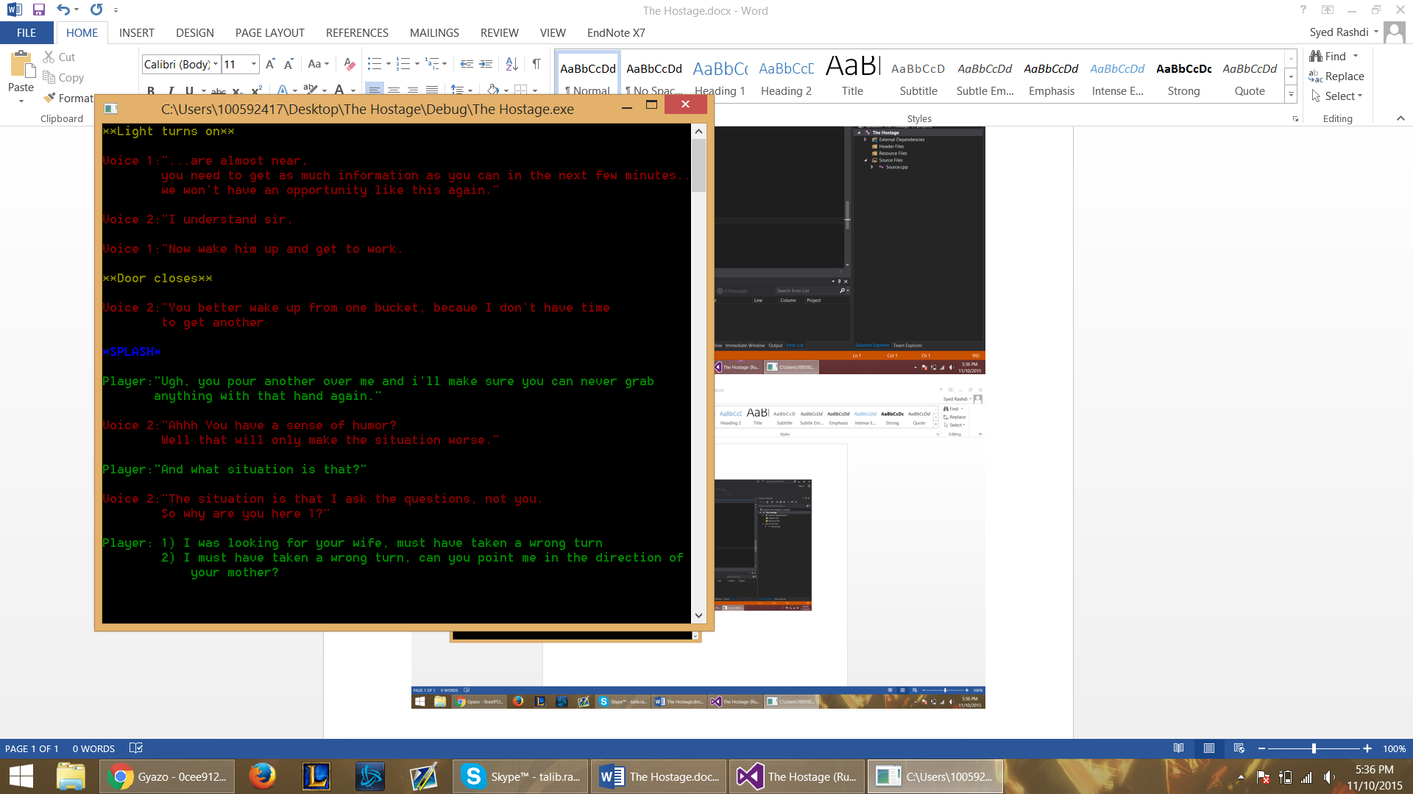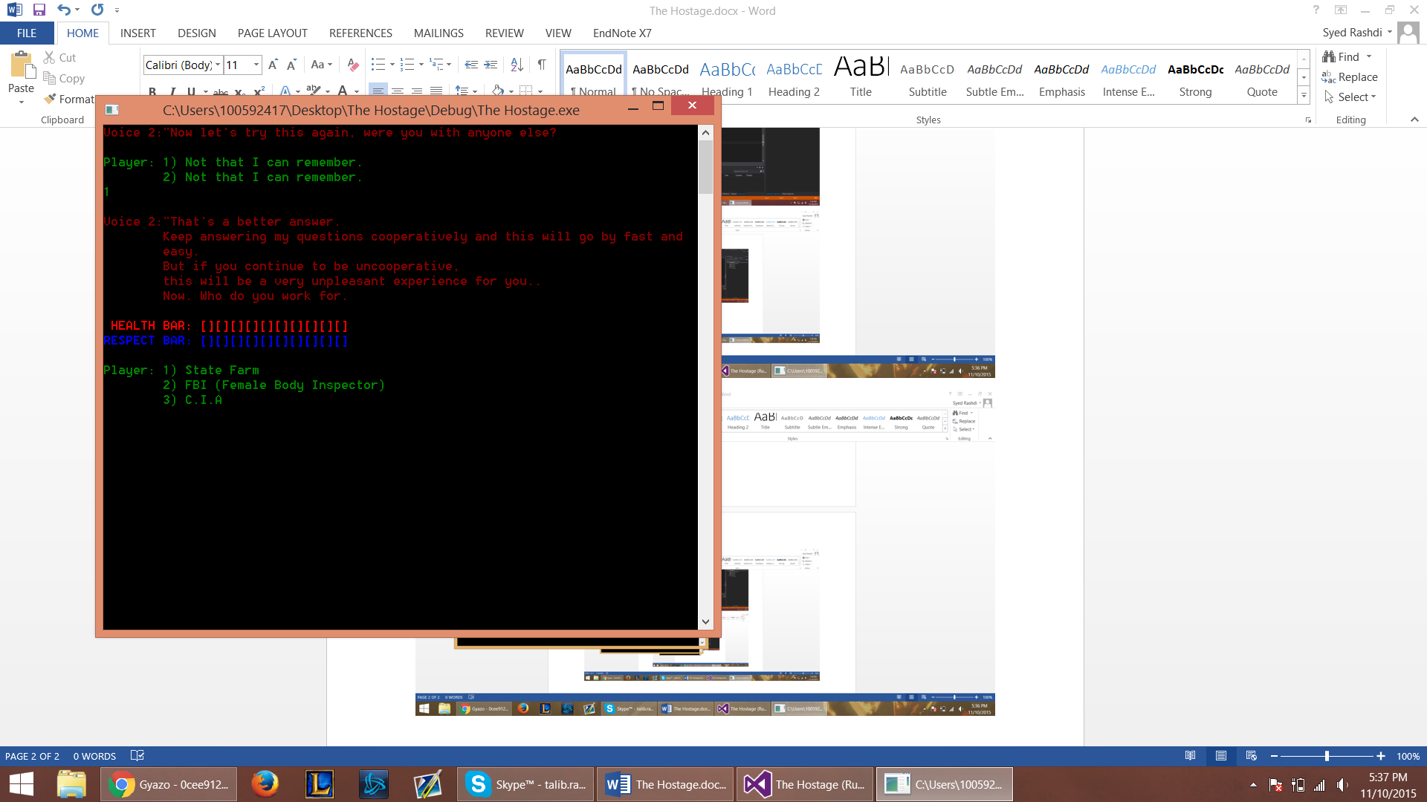

**Story**

Jason; the character controlled by the player; used to be a terrorist... A highly skilled terrorist who now works for the CIA after encountering over thirty CIA agents on one of his last planned act of terrorism; blowing up Madison Square Garden. To this day, Jason is still unaware of the identity to the man that tipped the CIA off. Although he is convinced that it was from his own terrorist group.

Once he had been taken into CIA headquarters, they gave him a proposition; go to prison for life, or to work for the CIA. Jason knew that by switching organizations, he would have to infiltrate his own terrorist group in order to bring them down. Seeking revenge on the people who turned against him, Jason now worked for the CIA.

The preparations are made and he is sent back to the Kamikaze’s headquarters. His mission is to stealthy infiltrate the hideout while killing the ones in charge. The objective is to gather as much information as possible while simultaneously setting up explosives around the complex. However things take a turn for the worse when Jason is unsuccessful during his infiltration, and knocked unconscious. He wakes up to find himself tied to a chair and with no knowledge of his whereabouts. While trying to recover his memory and discover where he is, the sound of footsteps grows louder. Two men walk into the room talking amongst themselves. The player overhears them talking about the lack of time. One of the men leaves the room as the other tries to wake up the player and begins interrogating him. The player secretly activates a homing beacon that alerts the C.I.A of the danger that he is in.

The player now has to stall for five minutes in order for the C.I.A to come rescue him. The player’s captor starts to interrogate him, in attempt to gain information from him about why he is there, who’s he working for, and possibly even killing him during the process. The player tries to stall by answering the questions as best as he can without giving away too much information. Every time he answers a question not to the liking of the interrogator, he get’s punched. Although, if the interrogator gets fed up with him, then the player will get shot. It is now up to the player to stall to save his own life.

**Character**

The Character’s name can be whatever the player desires, as the player has the option of what name they want. He is a comedic character with a good sense of humor, yet also is a former terrorist turned C.I.A agent. Having a strong ability to bullshit and persuade people, allows him lie in his best interest. He is in his mid 30s, and as a daughter that he cares for very dearly.

**Setting**

The player starts off in a room tied to a chair, blindfolded. The sound of heavy rain and strong winds inform him there is a storm, although he is inside somewhere. The terrorist hideout is located on a remote island only accessible by boat. Majority of the game however, takes place in the room; no windows, a chair, and a table.

**Interface:**

**Hud:**

Introduction comes onto the screen first. Afterwards when the game is being played, every line from each character is displayed on a separate line with a separate color; corresponding to their alliance (red being typical antagonist, while green is player). As you answer questions and take damage, the health and respect bars are displayed. The player will be able to gauge in their mind how risky they want to answer.

**Control:**

Player won’t be able to move and will have to answer the questions by typing in a number from one to three. If you give an option other than the ones provided you get beat to death. That will teach the players to play by our rules.

**Menu:**

No help system/tutorial needed since the gameplay is simple and self-explanatory. Entering ‘1’ will start the game, entering ‘2’ will exit the game.

**Audio style:**

As menu is reached after the group name is displayed, the game’s music starts to play continuously.

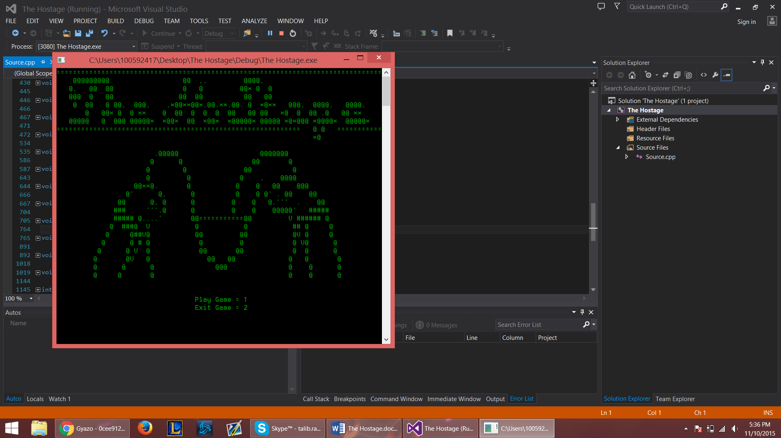

**Art:**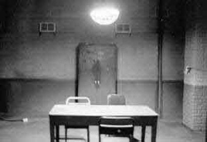

**Concept Art:**

- Small square room

- Only light hangs over the table

- Dim Room

- One metal door, 4 dirty white walls

**Style Guide:**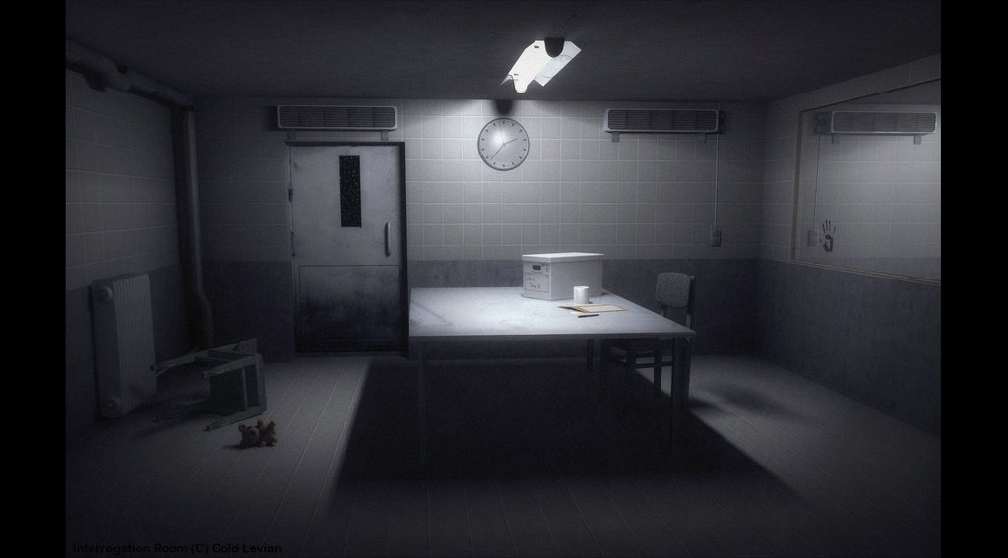

- A similar format to the games made my Telltale Games

- Player is given choices of dialogue to choose from

- Each decision may present consequences or advantages to the hostage

- The further the player progresses, the more the story will be revealed

**Characters:**

- The hostage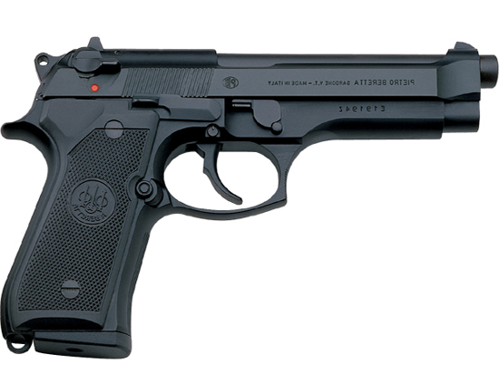

- The main interrogator

- Few other villains

- Rescue team

**Environments:**

- Night time, no windows

- Dirty; stench, insects.

- Cold

- Lightning storm

**Props & Equipment:**

- Handcuffs

- Head bag

- Weapons; knife, gun, etc.

- Table/chairs

**Asset List:**

**Textures:**

- Text (First Semester)

- 2D (Second Semester)

**Animations:**

- Upon being hit there are animations, there are also death animations done using ASCII art.

- Characters

- Room

- Props

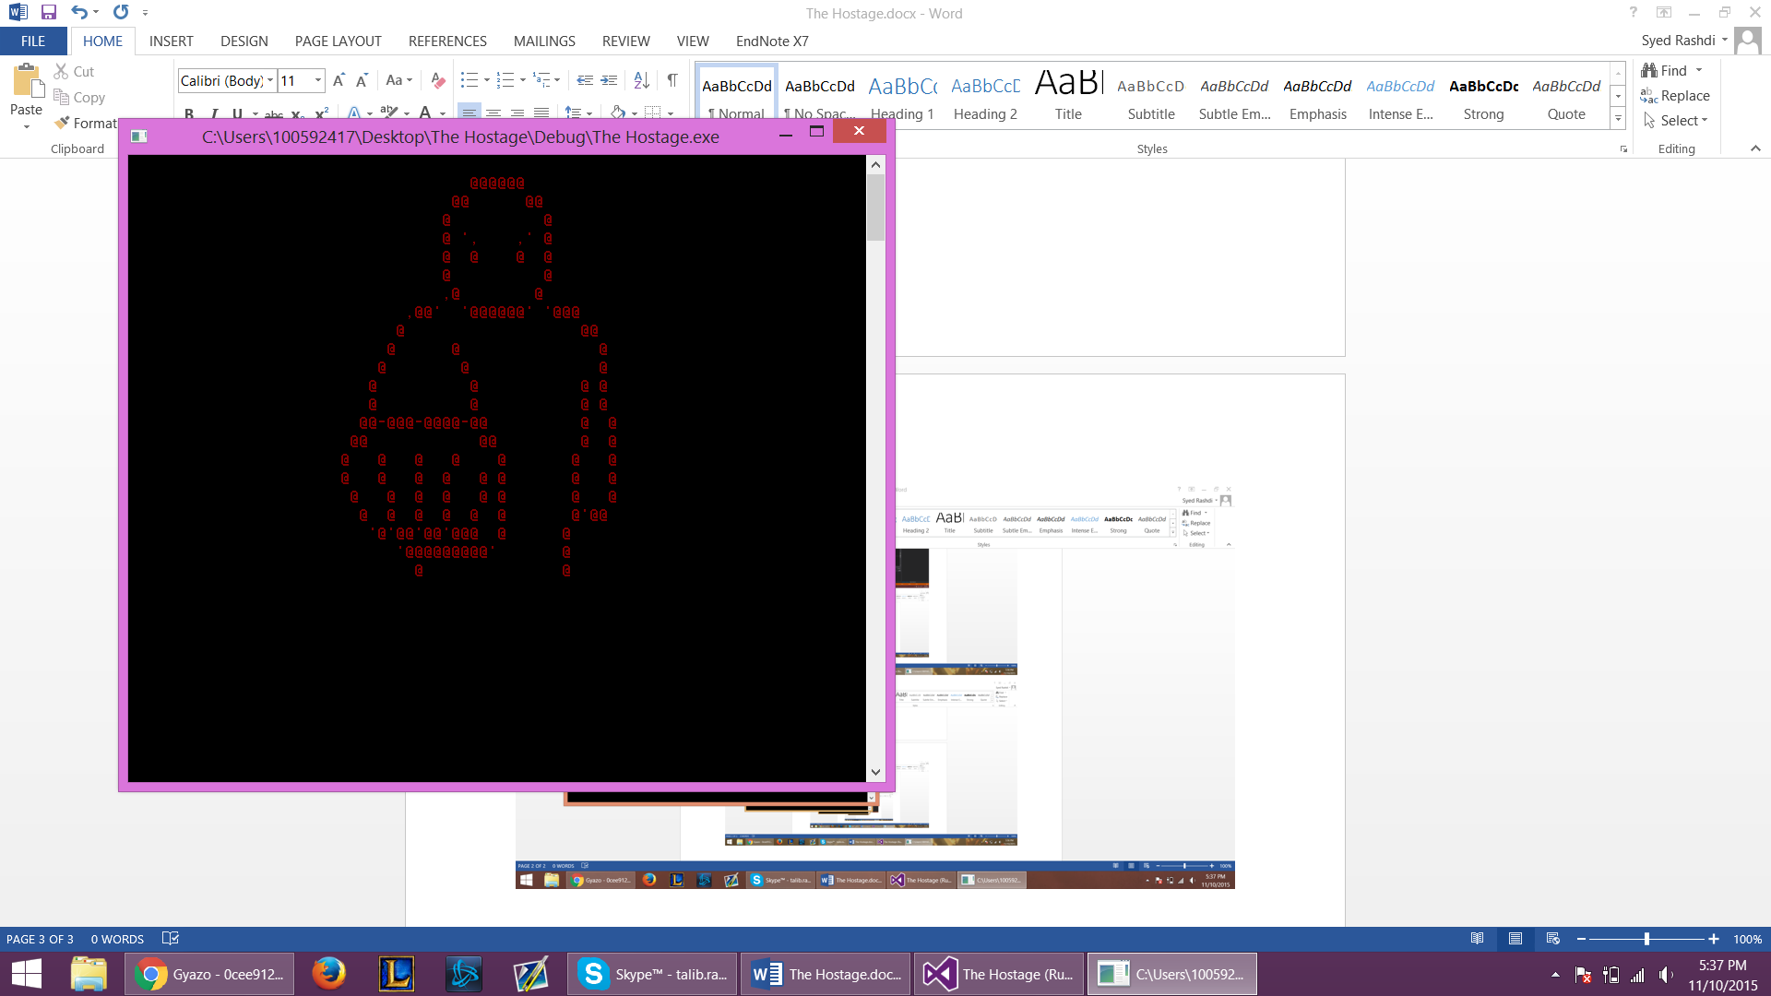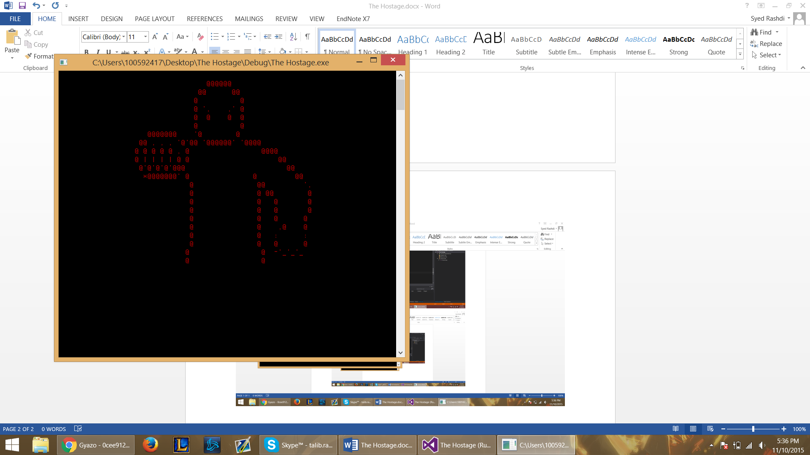

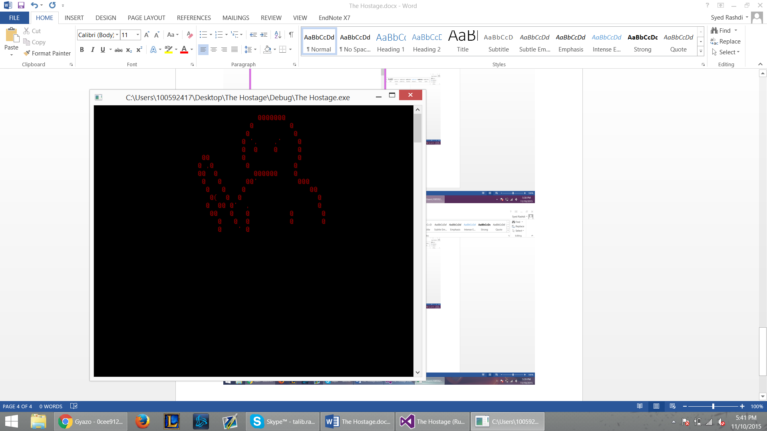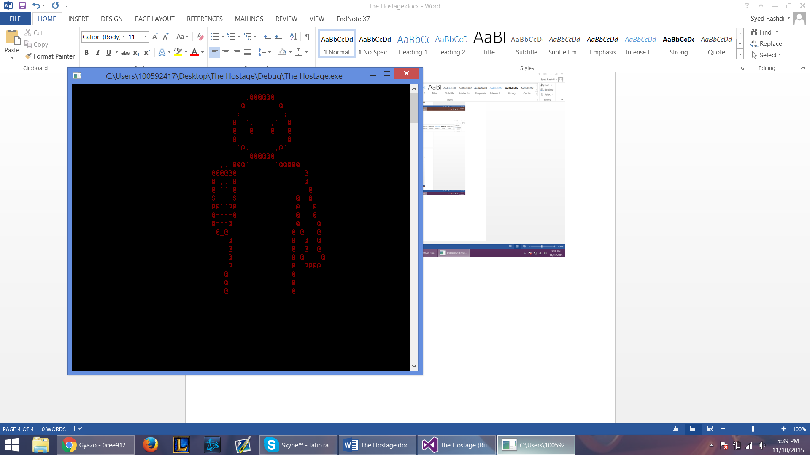

**GUI Effects:**

-Screen changes color when player takes damage

-Different colored text for differentiation.

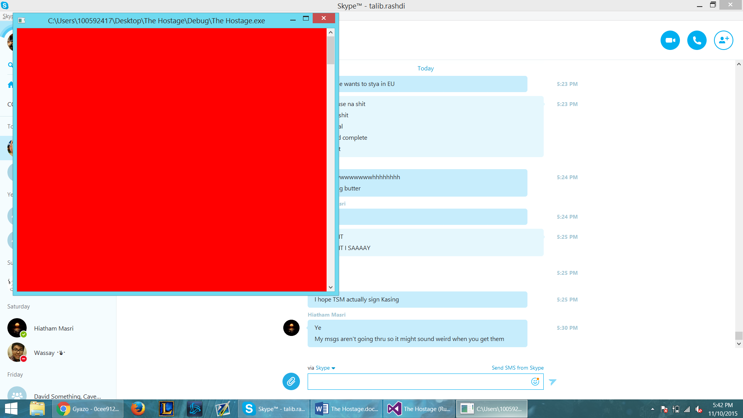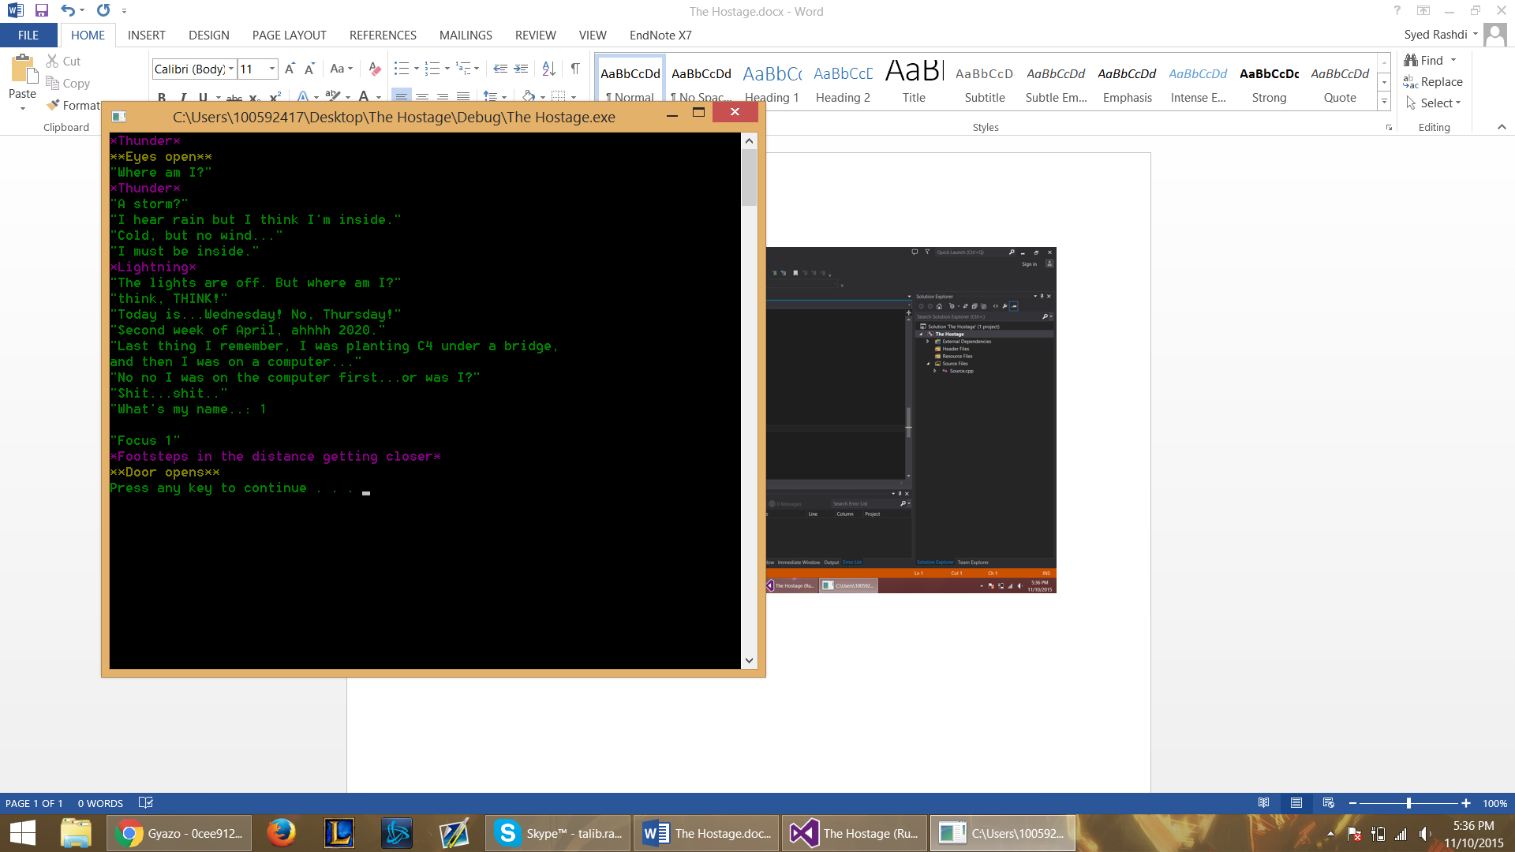

**Cutscenes:**

- Opening; bad men talking before introducing main character

- Ending; Two options: - Get killed -- player is shot with a gun from his interrogator.

- Get rescued -- player is saved by his organization.

**Sound Effects:**

- Character’s vocals

- Gunshot -- For death game over

- Punching sound -- For when damage is taken.

**Music:**

- Suspicious

- Creepy

- Dark

**Dialogue:**

- Between villains -- slight hints as to what is going on at the introduction.

- Between Hero/Villain -- the questioning and comebacks to witty answers.

**Menu Options:**

- Start -- starts the introduction and tutorial questions leading into game.

- Exit Game -- exits the game.

